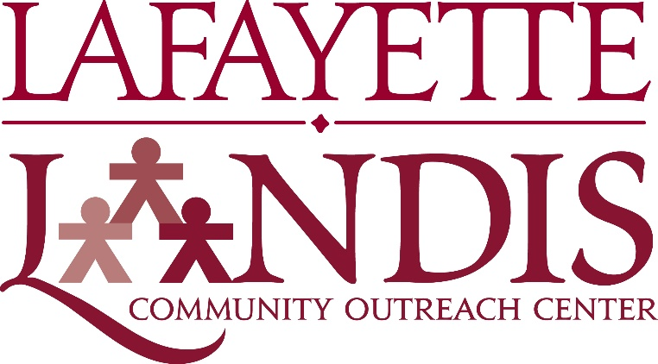

POSP KIC Staff Member

The Landis Center seeks passionate, committed students to serve as members of the POSP KIC Staff. The Pre-Orientation Service Program (POSP), coordinated by the Landis Center and the Leadership Committee, is an immersive service experience that unites First-Year Students, Returning Leaders, Faculty, Staff, and Community Members in an inclusive environment before the Fall Semester begins. Participants engage in meaningful service, build lasting relationships, and develop both as leaders and active citizens. POSP is the catalyst that encourages students to make connections through their involvement in meaningful service experiences, and results in increased appreciation of our Easton Community.

Job Responsibilities
During the spring semester, KIC Staff members meet bi-weekly to develop program outcomes, get to know their co-leaders, and develop their daily activity proposals. KIC staff plan and prepare all aspects of the 3-day KIC camp activities for local youth. KIC staff serve as station leaders during KIC Camp and assist the first-year counselor with the children. KIC Staff members are expected to communicate effectively, participate in on-going leadership development activities, and attend the POSP staff training prior to the program in August.

Desired Qualifications
Our ideal applicants will possess:
- Passion for a particular issue and/or program
- Experience with POSP or a similar camp program, specifically in working with children in a camp or after school setting
- Commitment to creating a sense of belonging for students and community members from all backgrounds
- Demonstrated capacity for critical thinking around complex social issues
- Ability to commit between 1-3 hours per week to POSP responsibilities through the spring semester

Additionally, we seek applicants who are:
- Professional, mature, and congruent in values
- Positive and flexible during times of challenge or change
- Self-motivated and able to manage multiple responsibilities simultaneously
- Resourceful and organized
- Detail-oriented and willing to serve as an authority figure as camp staff

Time Commitment

POSP KIC staff members are selected in February and spend approximately 1-3 hours per week during the spring semester. Additionally, KIC staff members arrive on campus approximately 10 days prior to the start of fall classes and spend 6 full days executing their POSP responsibilities.

Compensation

POSP KIC Staff members earn a modest stipend ($50). All early arrival housing expenses are covered and meals during the training and program are provided.

